**Brooklyn torah gazette**

**For parshas mikeitz 5782**

Volume 6, Issue 11 (Whole Number 266) 30 Kilev 5782/ December 4, 2021

**Printed L’illuy nishmas Nechama bas R’ Noach, a”h**

For a free subscription, please forward your request to [***keren18@juno.com***](mailto:keren18@juno.com)

**700-Year-Old Illuminated Machzor Sells for Record-Breaking $8,307,000**

**By Daniel Keren**

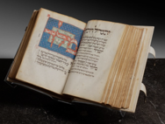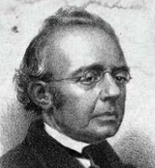

**The Luzzatto Machzor Samuel David Luzzatto**

Recently (October 19th), Sotheby’s a British-founded American multinational corporation headquartered in New York City, and one of the world's largest brokers of fine and decorative art, jewelry, and collectibles with 80 locations in 40 countries around the globe held an important Judaica auction that made headlines with the sale of $8,307,000 of the now famous Luzzatto Machzor, that broke the record for the highest price ever paid for a Hebrew manuscript.

This medieval Machzor was handwritten and illuminated in Southern Germany either in the late 13th or early 14th Century by a sofer (scribe) believed to be named Avraham. It is believed to have been created from a rich member of a Bavarian Jewish community. Its pedigree has subsequently traced this rare surviving Ashkenazi handwritten and illuminated to owners in the Alsace section that is currently in France, the Lake Constance region where Germany, Switzerland and Austria meet, northern Italy and France.

The machzor is named after the 19th Century Italian Judaica scholar Samuel David Luzzatto (1800-1865). Five years after Luzzatto’s death, the beautifully illuminated and illustrated High Holiday prayer book was purchased by the Alliance Israelite Universelle.

One hundred and fifty-one years later this unique Machzor was sold as mentioned last month for at the Sotheby’s Important Judaica auction in New York City for a record-breaking $8,307,000 (not including sales tax which at a rate of 8.875 would add another $737,246) for a mind-blowing grand total of $9,044,246. The Luzzatto Machzor was purchased by an anonymous American buyer.

If you would like to learn more about this unique Machzor, you can google – The Luzzatto High Holiday Mahzor – Judaica – Sotheby’s and you can read a detailed 16-page description from the Sotheby’s Catalogue chockfull of illustrations from the historic Yomim Noraim prayerbook.

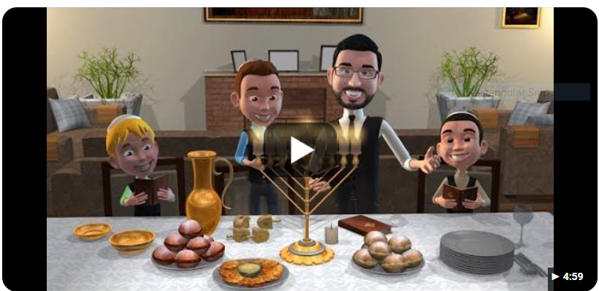

**Animated video of Micha Gamerman celebrating Chanukah**

This coming Sunday evening readers of the Jewish Connection will join our brothers and sisters around the world in celebrating the first night of the eight-day holiday of Chanukah that celebrates the miraculous victory of the family of Kohanim – the Hashmonaim against the Greeks in the year 3621/140 Before the Common era that resulted in capturing control of the Second Beis Hamikdosh and purifying the Holy Temple in Jerusalem from its spiritual desecration by the forces of Hellenistic culture.

In addition to a time for eating fattening high caloric latkes and sufguniot (donuts), Chanukah is also a time to sing traditional songs such as Haneirot Halalu, Maoz Tzur and Oh Chanukah! Oh Chanukah!

Google – Chanukah Medley with Micha Gamerman – to enjoy a delightful five-minute animated video version of the Brazilian singer singing beautiful songs celebrating the Festival of Lights.

Other more recent compositions celebrating Chanukah include the following titles from the Macabeats – (1) Candlelight 2020 or (2) Candles on the Sill or (3) Latke Recipe. You can google all of these holiday tools by inserting before the title song either YouTube or the name of the group Macabeats.



**Macabeats 2020 Chanukah - video celebrating Candlelight**

Another modern musical rendition you might enjoy is – Six13 – Bohemian Chanukah. Or you might want to listen to YouTube -Standfour – Eight Nights – Hannukah Mashup. You could also google - YouTube 8th Day – Miracle of Light.

If you have 27 minutes to enjoy an old-style action-packed radio play written by Chaim Clorfene and Simcha Gottlieb portraying the miracle of Chanukah as a victory of Jewish spirit over the forces of assimilation, then make sure to google – The Chanukah Story – Miracle of the Maccabees – Chabad.org

For more options on the Festival of Lights, whether it is songs – both traditional or modern versions, stories of inspiration or informative lectures – you can google such websites as Chanukah TorahAnytime.com or Aish.com – Chanukah or Chanukah 2021 – Chabad.Org

Until we meet again after the holidays have a wonderful celebration of this beautiful eight-day holiday and may the inspiration illuminate us in our galus that hopefully will see the coming of our long-awaited Moshiach who will help us rebuild the Third and eternal Beis Hamikdosh.

*Reprinted from the November 26, 2021 edition of the Jewish Connection.*

**Shabbos Chanukah:**

**The Bais HaMikdash -**

**Power Source of Spirituality**

**By Rabbi Bentzion Shafier**

**Founder of TheSmuz.com**



The *Bach* commenting on *Tur Shulchan Aruch* explains that the decrees of the *Yivanim* against the Jewish people occurred because the Jewish people became “*lax in their service.*”

Earlier in history, the *Bais HaMikdash* had been the center of life, the pride of every Jew. Going up to Yerushalayim three times a year was looked at with excitement and great anticipation, and the effect of the service was appreciated by all. However, at the time of the Chanukah events, that appreciation was long gone. While the *Kohanim* still brought the *Korbonos*, the service in the Bais HaMikdash had lost its luster and glory.

The *Bach* seems to be saying that all that was to befall the Jewish people was because we no longer approached the *Avodah* with the appropriate sense of purpose, and therefore it was taken from us. This, however, becomes difficult to understand when we take into perspective what was actually happening in those days.

**The State of the Union**

At the time of Chanukah, there was much wrong with the spiritual state of the Jewish people. Ignorance had become profound, and entire generations were no longer brought up in the ways of Torah. The Greek/Syrian philosophy had taken hold, and many, many Jews considered themselves more Greek than the Greeks. In their homes they spoke the language of *Yavan*. They schooled their children in the ways of *Yavan*, and all that they aspired for was acceptance in Greek society.

According to the *Megillas Chasmonaim*, the Jews of Yerushalayim asked Antiochus to rename their city Antioch in his honor. They even sent a contingency asking him to erect a gymnasium in Yerushalayim. A gymnasium was not merely a hall for the practice of Greek sports; it was a center of idol worship. It represented a house of Greek culture for the specific function of propagating the Greek ideology and all that it stood for.

Initially, Antiochus refused. Finally, the Jews of Yerushalayim gathered together 360 talents of silver – a king’s ransom – to bribe Antiochus to erect such a building. He agreed, and the Megillas Chasmonaim opens up with the statement: “*They erected a gymnasium in Yerushalayim.”*

The Ramban on Chumash says, “*If not for the Chasmonaim, Torah would have been forgotten from the Jewish people.*” If so, why did the *Bach* say that *the* reason for the decrees was the Jews being lax in the *Avodah*? There seem to be many other things going wrong.

**Spiritual Fuel Source**

The answer seems to be that in spiritual manners, there is no stagnation. A person is either going up or going down. The concept of remaining static doesn’t exist. If a person has the spiritual fuel that he requires, he ascends level after level. If not, he declines. That is the reality. That is the way Hashem created the world. The *Bais HaMikdash* was the nuclear reactor that fueled the spiritual needs of the world.

The nation as a whole took a downturn because the source of all *Ruchnius* was no longer potent. It had lost its luster in the people’s eyes, and so it was no longer providing the life-giving nourishment that HASHEM created it to give. The Jewish people are one unit, inextricably tied together in fate and spiritual level. The core of our spiritual energy in those days was the *Bais HaMikdash*. The *Avodah* was the lifeline and fuel source for the nation.

Since it was no longer practiced properly, it couldn’t maintain the spiritual needs of our people. The reason the Jews of Yerushalayim became enamored with Greek culture was because the furnace providing the level of spiritual power was no longer functioning at capacity. The *Avodah* no longer accomplished its desired effect, and the Jewish Nation itself was in grave danger.

The only cure was for the Jewish people to reach a new understanding of the primacy of the *Avodah* and to rededicate themselves to the service in the Bais HaMikdash. When led by the *Chasmonaim*, Kohanim who did the *Avodah* and who were willing to sacrifice their lives for it, the nation was rededicating themselves to the centrality of the Avodah. Then the *Bais HaMikdash* could be reestablished and pump out the spiritual nourishment needed to keep the *Klal Yisrael* whole.

Kiruv - The Mitzvah of our Generation

This concept is especially relevant in our times when as much as 90% of our nation is made up of non-practicing Jews. While the numbers may seem daunting, nevertheless, we live in amazing times. There is a powerful receptivity amongst our people –religious and not yet religious – for growth. People hunger for truth and meaning in their lives, and the Torah is only pure source that fills that need.

Clearly, the mitzvah of our generation is *Kiruv*. And as such, it is an obligation upon each of us to do all that we can to help our brothers who were brought up bereft of their heritage. From that aspect, the work is clear. We must go out and do whatever is in our power to help – whether teaching classes or inviting non-religious co-workers to our homes, whether joining Partners in Torah or contributing to Kiruv programs. The work is endless, but the potential is stellar.

At the same time, we can’t lose sight of the reality that these attempts succeed only because of the spiritual state of our nation. We no longer have a *Bais HaMikdash*. Now, our Yeshivas and Kollels are the nuclear furnaces that provide the spiritual fuel for the world. If our own Torah study is on a high level, and we are pumping out the vital spiritual fuel needed, then with HASHEM’s help, all of these efforts will succeed. However, if we allow the spiritual reactors of our people to decline, then all of the best efforts in the world will not meet with success. The underlying energy source of it all will be lacking.

*Reprinted from the current website of TheShmuz.com*

# Rav Avigdor Miller

# On Dinah’s Sin and Television



**QUESTION:** **When Dinah was wronged by Shechem, what was the sin for which she was punished? And also why was Shechem not punished?**

**ANSWER:** Now, Shechem was punished; it says openly that they slew him by the sword. If they cut his head off, that’s a punishment.  
  
 And Dinah was punished because ותצא דינה … לראות בבנות הארץ  – Dinah went out … to look at the daughters of the land (Vayishlach 34:1). That’s a great error! A Jewish daughter should not mingle with any others. At night, a Jewish child should not go out in the street. The street, even in the better days, was a gehinom. Today it is a gehinom sh’begehinom but even fifty years ago, if a parent allowed their child to walk out in the street at night, the child was going to mingle now with goyim, or with wicked Jews, it’s the fault of the parent and the child.   
 And therefore, although Dinah’s intentions to a certain extent were good; I’m sure Dina went out to see what she could she do for the daughters of the land. Because her father Yaakov was always preaching about Hashem; wherever he went he was ויקרא בשם השם –– he spoke about Hashem all the time just like his father and grandfather did. And so, she went out to see; maybe she on her own could do something for the daughters of the land. Maybe she could make some kind of a little party, and teach them about the Creator; make a brocha on something and teach them that He is the one Who really created it.

**You Must Know How to Swim Yourself**

But you don’t teach swimming lessons unless you can swim yourself. And you don’t try to teach other people when you are not impervious, when you are susceptible to bad influences.

There’s a man he calls me up, he has a relative, a girl, and he wants to teach her to be frum. So, I told him, “Forget about it!” It says אברהם מגייר את האנשים – Avraham was converting the anashim, the men, not the nashim. Men don’t try to convert women. It’s a dangerous business!

And therefore, Dina was not able to swim yet and she went out to save somebody else. She went out לראות בבנות הארץ, to see the girls of the land. Don’t look at the daughters of the land! You’re looking for trouble. Even if you’re sitting in your homes and you’re looking at them on television, it’s the same thing; you’re endangering your life.

Not only your neshama; you’re endangering your life. Television is a sakana for life. Everybody knows that children are losing their lives because of television. They learn to do violent and dangerous things and their lives are ruined by the examples they see.

**Anyone with a Television is a Reckless Parent**

Anybody who has a television in his home today is a reckless parent; he doesn’t care. He’s entirely irresponsible! Not only for his children but for himself too. You have to take yourself in hand. And the first thing to do if you are a decent person is to take the television and give it a heave through the second story window. That’s number one.

And I don’t mean maybe. Anybody who persists today in having a television today – I don’t care how old you are. You’re going to say, “Well, it’s not going to spoil me anymore.” That means you are so spoiled that it can’t do you harm anymore. But I’m telling you, no matter how spoiled you are, you are becoming worse.

And I don’t care what you say. I know a lot of people, Othodox people, have televisions and they ridicule me when they hear this admonition. But that’s not my fault; I’m doing my duty. But they have to know that there is a very big question about their portion in Olam Haba. הקורא בספרים חיצוניים אין לו חלק לעולם הבא.

And television is the essence of sefarim chitzoni’im – it’s much worse because when you see it live, when you see it in action, in color, it has a terrible influence on the mind. I’m very much afraid about those peoples’ chelek in Olam Haba. I don’t care how frum they are; because in their pniyimos, inside of them, they should know they are corroded; they are rotten through and through – no matter how they try to be good.

And therefore, when Dina went out, although she did it with a good purpose, but her purpose backfired. Because you have to be prepared if you want to change other people; otherwise they are going to change you.

*Reprinted from the November 19, 2021 email of Toras Avigdor (Tape 843)*

**Public Menorah Lighting in Front of the White House**



*Lighting the National Menorah at Lafayette Square in front of the White House in Washington, D.C. on Sunday night, November 28th.*

**Rabbi Berel Wein on**

**Parshat Mikeitz 5782**

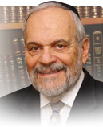

There is a famous statement that reverberates throughout Jewish society over the ages that states: "…what cannot be solved by wisdom, will eventually be solved by the passage of time." It seems that time is never neutral, and that its passage certainly influences decisions and events that take place in human society.

Our rabbis have commented that the miraculous deliverance of Joseph from his prison cell and his rise to power was, to a certain extent, due to the time that had passed, and with the heavenly intervention in human events.  It suddenly became the time when Joseph should be set free and achieve greatness and dominion. That is why the Torah reading, with this unbelievable mysterious story, now begins to unfold after time has elapsed and when the correct moment for the divine will to be activated in human affairs.

In dealing with business and commerce, we are all aware of the axiom that “timing is everything.” Well, that is not only true in matters of finance and business but it also a basic axiom of life and of human history. What can be accomplished at a certain time becomes impossible to achieve either earlier or later. The examples regarding this truism are various and innumerable. It is the circumstances that the passage of time create that fashions the *milieu* in which events can take place, and individuals can rise to greatness or be defeated.

The timing of heaven and G-d's guidance in human affairs is always mysterious, inexplicable, and irrational to us ordinary mortals. However, in retrospect, one sees the perfection involved, and the exquisite nature of the timing that governs human events. King Solomon taught us in Kohelet that there is a time for everything to occur, and that everything has its time.

Among the many fallacies of human thought is the idea that we not only control the occurrence of events, but, somehow, we also have the power to decide when those events should take place. It should be obvious to all that we do not control time. In fact, unfortunately, we allow time to control us, our behavior, our schedules and even our goals. It never enters our minds that somehow time is really beyond the boundaries of our powers of control, and beyond even our most fervent wishes and desires.

In truth, most of our lives are almost predetermined: when we are born, and the circumstances of the present world in which we live. It takes a famine of epic proportions to propel Joseph to greatness, political stature, and governmental power. Heaven will use those times and circumstances to reunite the family of Jacob, and to begin the story of Jewish exile and redemption. Everything that happens from then on, in the family of Jacob, will be a product of the times and the society in which they find themselves. They will go into exile on schedule and will also be redeemed at the right time. But being human, they will not all be aware of the schedule itself.

*Reprinted from the current website of rabbiwein.com*

**Recognizing the Importance**

**Of a Joseph’s Dreams and**

**Its Legacy to Every Jew**

**From the Talks of the Lubavitcher Rebbe**

**Rabbi Menachem Mendel Schneerson, Zt”l**

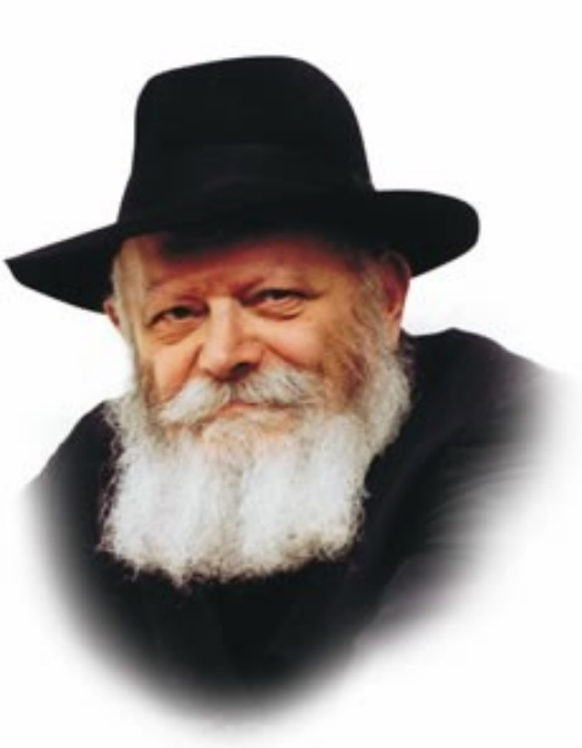

The beginning of this week's Torah reading, Miketz, describes Pharaoh's dreams at great length.

The Torah goes into much detail relating his first dream about the cows, then describes the second dream concerning the ears of corn. The portion then goes on to give Yosef's interpretation of these dreams, i.e., their allusion to the seven years of plenty and seven years of famine to come.

Why does the Torah provide us with all this information? Indeed, the Torah's sole intent in telling us these details is to let us know how Yosef came to be second in command over all of Egypt.

But what difference does it make how Yosef attained his post? Why does the Torah describe Pharaoh's dreams so specifically?

**The Significance of the Tzadik**

**And What Happens in Our World**

The answer has to with the particular lesson the Torah is teaching here, that everything that happens is because of the "tzadik (righteous person) who is the foundation of the world." In his time Yosef was this tzadik, and all of the G-dly influences and blessings that come down into the world had to pass through him.

In the previous Torah reading we learned that Yosef also had dreams, in which many G-dly secrets were revealed. Because this was the manner in which these matters were revealed the entire world followed, to the extent that even Pharaoh, the most powerful ruler in the ancient world, had to learn about the coming years of plenty and famine through the medium of dreams. Because the tzadik of the world, Yosef, had dreams in which he received G-dly knowledge, so, too, did the Egyptian king have to receive a foreknowledge of things to come in this manner.

**The Mistaken Concept that Jew Must**

**“Fit” themselves in the Non-Jewish World**

There are some people who mistakenly think that Jews must somehow "fit" themselves into the world, conforming to the same rules of conduct and adopting the same opinions as the gentile nations. However, this path is not a correct one, for as we learn from Pharaoh's dreams, everything that happens in the world is the direct result of the Jew.

It is the Jew's behavior that determines the course of events, something he must bear in mind when he encounters inappropriate behavior. But in truth, by altering his own thoughts and conquering his own lusts, the world itself will automatically change and follow his lead.

*Reprinted from Reprinted from the 5757/1996 Vayeishev edition of L’Chaim Weekly, adapted from Likutei Sichot, volume31.*

**Menorah Placement**

**By Rabbi Chaim Hillel Raskin**

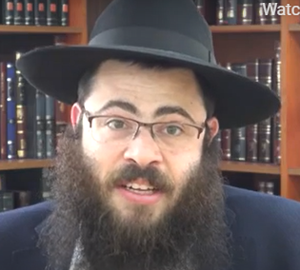

Where should yeshiva students light their Chanukah menorah? In Talmudic times, the menorah was lit outside at the entrance to one’s courtyard, and if it was missing, passerby may think he didn’t light.

The Rosh, therefore, writes that one must light by the home where he sleeps, even if he consistently eats elsewhere with his relatives, since the passerby don’t know he eats somewhere else.1

The Rashba, however, rules that nowadays one should light in the location where he normally eats.2 In Shulchan Aruch, the Mechaber rules that one lights by the room where he sleeps.

**The Opinion of the Rosh**

The Rama writes that today when we light completely indoors, and passerby won’t notice whether or not he lit, the custom is to light where one normally eats, and perhaps even the Rosh would agree to this.3

How does this apply to a bochur who sleeps in the dormitory and eats in the lunchroom? Some contemporary poskim hold that he should light in the lunchroom, following the simple reading of the Rama.4

Others argue that the primary place is the dormitory where he sleeps, as he would prefer to eat there as well if only, he could.5 Additionally, unlike a personal dining room, the yeshiva’s lunchroom is not in use most of the day.6

Reb Moshe Feinstein and many others rule to light in the dormitory, especially since a dormitory room is allocated to the bochur more specifically.7 It is also interesting to note the [Lubavitcher] Rebbe’s recommendation that children should light near their bedroom.8 However, whenever there is a safety concern, he should light in the lunchroom.9

It can be noted that contemporary batei midrash (zal)— where one snacks occasionally as well—are also considered the students’ "home" and the menorah can be lit there.10

Moreover, there is more pirsumei nisa there than in the lunchroom and it has an advantage in this respect.11 In conclusion, yeshiva students should preferably light in the dormitory if allowed by hanhala. If there are safety concerns, they should light in the lunchroom, or better yet, by the zal.

1 .טור או"ח סי' תרע"ז בשם אביו הרא"ש. 2 .שו"ת הרשב"א ח"א סי' תקמ"א-ב. 3 .שו"ע או"ח שם ס"א. 4 .ראה ס' מצות נר איש וביתו סי' ה' ס"ט אות כ"ד. 5 .ראה שו"ת שיח יצחק סי' שנ"א. 6 .שו"ת בדי הארון או"ח סי' כ"ז ע"פ ט"ז סי' תרע"ז סק"ב. 7 .אג"מ או"ח ח"ד סי' ע'. וכן פסק מקראי קודש חנוכה הע' צ"ח )בשם הגר"מ אליהו ע"ה ומו"ז ח"ו סי' ח'(. 8 .תו"מ תשמ"ח ע' 64. 9 .ראה ס' באהלה של תורה ח"ב סי' ק"א )וכן מובא בהליכות שלמה מועדים ח"א ע' רע"ג(. 10 .ראה שו"ת שבה"ל ח"ג סי' פ"ג. 11 .מקראי קודש חנוכה ע' ק'

*Reprinted from the Parshat Vayeishev 5782 of the Merkaz Anash’s The Weekly Farbrengen edited by Rabbi Shimon Hellinger.*

**Thoughts that Count for**

**This Week’s Parsha**

*Behold, seven ears of corn came upon one stalk healthy and good, and behold seven thin ears sprung up after them* (Gen. 41:5-6)

In Pharoah's dream, the seven good ears were all on the same stalk, while the seven thin ones were not. This was to show that the seven years of abundance were consecutive, but the seven years of famine were not. Yaakov arrived in Egypt during the second year of famine. He blessed Pharoah, and the Nile rose and the famine ceased temporarily. After Yaakov died seventeen years later, there were five more years of famine. *(Klei Yakar)*

Pharoah said to his servants, "Can there be found another such person who has G-d's spirit in him?" (Gen. 41:38)

Pharoah attempted to trick Yosef to see if Yosef could interpret the dream properly. Pharoah dreamed that he was standing on the river, but he told Yosef that he was standing on the bank of the river. Yosef correctly interpreted every other detail of the dream, but told Pharoah, "G-d revealed no interpretation for your standing on the bank of the river. Possibly, this didn't appear in your dream." *(Chasidei Avot)*

*If I lose, I lose.* (Gen. 43:14)

Yaakov was afraid that he would lose yet another son in Egypt when his sons brought Binyamin to Egypt. The first "I lose " is for Yosef and Shimon who were still there, and the second "I lose" is for Binyamin. Yaakov was also referring to the Exile of the Jews. The first "I lose" is for the first Holy Temple that was destroyed, the second "I lose" is for the second Holy Temple that was destroyed. After the Redemption, G-d will give us a third Holy Temple that will never be destroyed. *(Bereishit Rabba)*

*He took Shimon and arrested him before their eyes* (Gen. 42:24)

Yosef made a point of arresting Shimon in front of his brothers, but as soon as they left, Yosef took him out of prison and gave him food and drink. He had no intention of keeping Shimon in jail, as he had committed no crime. Yosef wanted his brothers to bring Binyamin to Egypt, but since he wouldn't be able to recognize Binyamin, he was afraid that his brothers would just bring any person off the street and try to pass him off as Binyamin. He kept Shimon so that Shimon would be able to correctly identify the person they brought as Binyamin. *(Panim Yafot)*

*Reprinted from Reprinted from the 5757/1996 Mikeitz edition of L’Chaim Weekly Compiled by Rabbi Moshe Bogomilsky and printed in Vedibarta Bam*